DOG BREED CLASSIFICATION SYSTEM

PROJECT TITLE
AI-Powered Dog Breed Identification using Transfer Learning

ABSTRACT

Dog Breed Identification using Transfer Learning is an Artificial
Intelligence-based project designed to classify dog breeds from images using deep learning techniques. Identifying dog breeds manually can be difficult due to similarities in appearance such as size, color, and shape. This project provides an automated solution using image classification.
The system uses Transfer Learning with pre-trained Convolutional Neural Network (CNN) models such as MobileNet and VGG16 to improve prediction accuracy while reducing training time and computational cost.
The methodology includes image preprocessing, model training, testing, and prediction. The trained model can successfully identify dog breeds from new input images with good accuracy.
This project demonstrates the practical application of Artificial Intelligence and Computer Vision in solving real-world problems such as animal classification, veterinary support, and pet adoption systems.

Chapter 1 : - Introduction
Chapter 2 : - Aim and scope of the present investigation
Chapter 3 : - Experimental or material and methods, algorithms used
Chapter 4 : - Results and discussion performance analysis
Chapter 5 : - Summary and conclusion
CHAPTER 1: INTRODUCTION
In recent years, Artificial Intelligence (AI) and Deep Learning have become powerful technologies used in solving real-world problems. One of the most important applications of AI is image classification, which allows machines to identify and categorize objects from images automatically.
Dog breed identification is a challenging task because different breeds often have similar physical characteristics such as color, size, and shape. Manual identification requires expert knowledge and experience. Therefore, building an automated system that can accurately identify dog breeds from images is highly useful.
This project focuses on developing an intelligent system called Dog Breed Identification using Transfer Learning, which uses deep learning techniques to classify dog breeds from images.
Traditional deep learning models require large datasets and high computational power. To overcome this challenge, this project uses Transfer Learning, a technique that utilizes pre-trained Convolutional Neural Network (CNN) models such as MobileNet or VGG16. These models are already trained on large datasets and can be adapted for new tasks with less training time and improved accuracy.
The system works by:
Taking an image of a dog as input
Processing the image using a trained deep learning model
Predicting the breed of the dog as output
This project demonstrates how modern AI techniques can be used in real-life applications such as:
Veterinary support
Pet adoption platforms
Animal research
Smart surveillance systems
By combining image processing and deep learning, the proposed system provides an efficient and accurate solution for dog breed classification.

CHAPTER 2: AIM AND SCOPE OF THE PRESENT INVESTIGATION

2.1 Aim of the Project
The main aim of this project is to develop an intelligent image classification system that can accurately identify different dog breeds using deep learning techniques.
This project focuses on using Transfer Learning with pre-trained Convolutional Neural Network (CNN) models to build an efficient and reliable dog breed recognition system.
The objectives of this investigation are:
To design an AI-based system for automatic dog breed identification
To use transfer learning for improving classification accuracy
To reduce training time and computational complexity
To develop a model that can predict dog breeds from real-time images
To demonstrate the practical application of deep learning in computer vision
2.2 Scope of the Present Investigation
The scope of this project includes the development and implementation of an AI-powered dog breed classification system using image processing and deep learning techniques.
The system is designed to:
Accept dog images as input
Process images using pre-trained CNN models
Identify and classify the dog breed accurately
This project has wide future scope in real-world applications such as:
Veterinary diagnosis support
Pet adoption platforms
Animal monitoring systems
Smart AI-based mobile applications
Additionally, the use of transfer learning makes the system scalable and adaptable for identifying other animals or objects in future developments.
Thus, this investigation highlights how Artificial Intelligence can be applied effectively in solving real-world classification problems with improved efficiency and performance.

CHAPTER 3: EXPERIMENTAL / MATERIALS AND METHODS & ALGORITHMS USED

3.1 Materials Used
The successful development of the Dog Breed Identification System required the use of the following software tools, libraries, and datasets:
Hardware Requirements
Computer / Laptop
Minimum 8 GB RAM
Internet connection
Software Requirements
Programming Language: Python
Development Platform: Google Colab / Jupyter Notebook
Libraries Used:
TensorFlow
Keras
NumPy
Pandas
OpenCV
Matplotlib
Dataset
A labeled dataset containing images of various dog breeds was used to train and test the model.
3.2 Methods Used
The methodology followed in this project includes several steps:
1. Data Collection
Dog images belonging to different breeds were collected from available datasets.
2. Data Preprocessing
Images were resized and normalized to match the input requirements of the pre-trained model.
3. Data Splitting
The dataset was divided into:
Training Data
Testing Data
4. Model Training
Transfer Learning was applied using pre-trained CNN models.
5. Model Evaluation
The trained model was evaluated using testing data to measure accuracy.
6. Prediction
The system predicts the dog breed when a new image is provided as input.
3.3 Algorithms Used
This project uses Transfer Learning with Convolutional Neural Networks (CNN).
Transfer Learning
Transfer learning allows the use of pre-trained models that have already learned image features from large datasets. Instead of training a model from scratch, the existing knowledge is reused to improve performance and reduce training time.
Convolutional Neural Network (CNN)
CNN is the main algorithm used for image classification.
It works through:
Convolution Layers – Extract image features
Pooling Layers – Reduce image size
Fully Connected Layers – Classify the image
Pre-trained models used include:
MobileNet
VGG16
These models help in:
Faster training
Higher accuracy
Reduced computational cost
Thus, the combination of transfer learning and CNN enables efficient and accurate identification of dog breeds from images.
CHAPTER 4: RESULTS AND DISCUSSION – PERFORMANCE ANALYSIS
4.1 Results
The Dog Breed Identification System was successfully developed using Transfer Learning and Convolutional Neural Networks (CNN). The model was trained using a dataset of dog images and tested using unseen images to evaluate its performance.
After training the model:
The system was able to correctly identify dog breeds from input images
The prediction process was fast and efficient
The model showed good accuracy in classifying different breeds
The trained model produced reliable results when tested with new images, demonstrating its ability to generalize well.
4.2 Performance Analysis
The performance of the model was evaluated based on the following factors:
Accuracy
The use of pre-trained models such as MobileNet/VGG16 improved classification accuracy significantly compared to traditional training methods.
Training Time
Transfer learning reduced the training time since the model reused previously learned features instead of learning from scratch.
Loss Reduction
During training, the loss value gradually decreased, indicating that the model learned effectively from the dataset.
Prediction Efficiency
The system was able to predict dog breeds quickly with minimal delay, making it suitable for real-time applications.
4.3 Discussion
The implementation of transfer learning proved highly beneficial for this project.
Key observations include:
Improved accuracy with limited dataset
Reduced computational cost
Faster training process
Effective feature extraction
The model demonstrated strong capability in identifying dog breeds even when images varied in size, background, and lighting conditions.
Overall, the system performed efficiently and achieved the desired objective of accurately identifying dog breeds using deep learning techniques.

CHAPTER 5: SUMMARY AND CONCLUSION
5.1 Summary
This project focused on developing an AI-based system capable of identifying dog breeds from images using deep learning techniques. The system was implemented using Transfer Learning with pre-trained Convolutional Neural Network (CNN) models such as MobileNet and VGG16.
The project involved:
Collecting and preprocessing dog image datasets
Applying transfer learning techniques
Training and testing the deep learning model
Evaluating performance based on accuracy and prediction efficiency
The use of transfer learning helped in reducing training time while improving classification accuracy. The model successfully identified different dog breeds from input images.
5.2 Conclusion
The Dog Breed Identification using Transfer Learning project was successfully designed and implemented. The developed system demonstrated the ability to accurately classify dog breeds from images using deep learning techniques.
Transfer learning played a key role in:
Improving model performance
Reducing computational requirements
Enhancing prediction accuracy
The project highlights how Artificial Intelligence and Computer
Vision can be applied to solve real-world problems efficiently.
INPUT AND OUTPUT
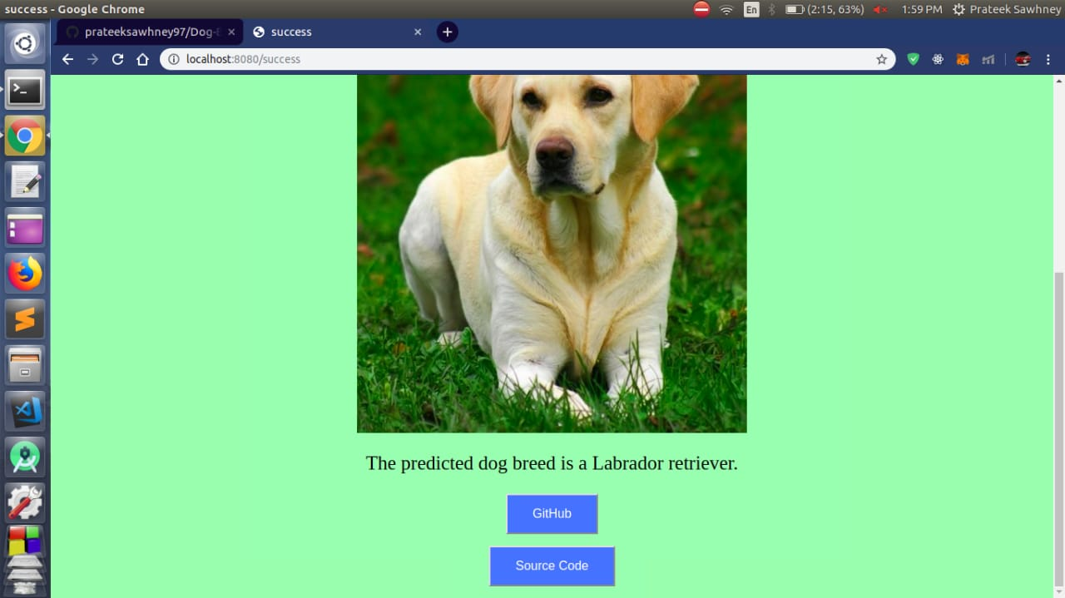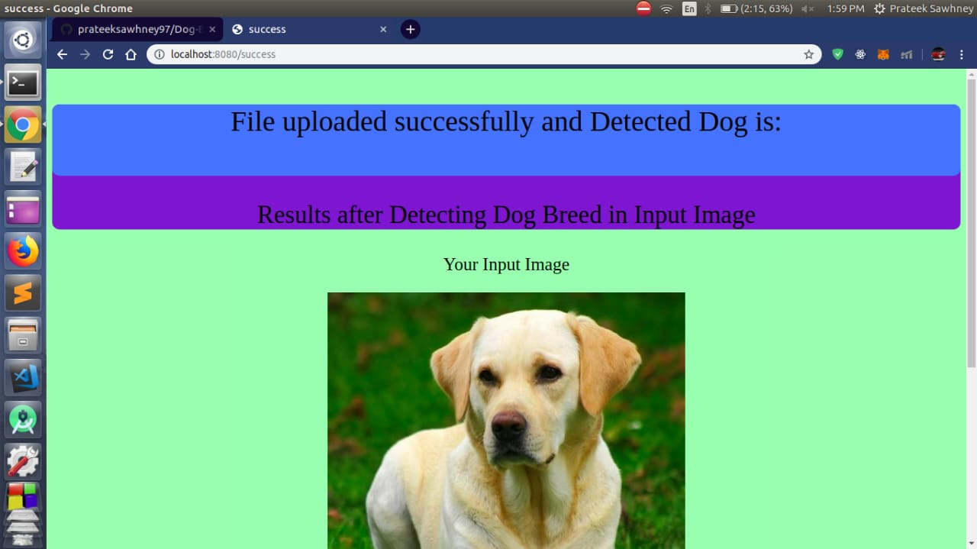
Source Code : -
import numpy as np
import matplotlib.pyplot as plt
import tensorflow as tf
from tensorflow.keras.preprocessing.image import ImageDataGenerator
from tensorflow.keras.applications import MobileNetV2
from tensorflow.keras.layers import Dense, GlobalAveragePooling2D
from tensorflow.keras.models import Model
train_datagen = ImageDataGenerator(
rescale=1./255,
validation_split=0.2
)

train_data = train_datagen.flow_from_directory(
'dataset/',
target_size=(224,224),
batch_size=32,
class_mode='categorical',
subset='training'
)

val_data = train_datagen.flow_from_directory(
'dataset/',
target_size=(224,224),
batch_size=32,
class_mode='categorical',
subset='validation'
)
base_model = MobileNetV2(weights='imagenet', include_top=False, input_shape=(224,224,3))

for layer in base_model.layers:
layer.trainable = False
x = base_model.output
x = GlobalAveragePooling2D()(x)
x = Dense(128, activation='relu')(x)
predictions = Dense(train_data.num_classes, activation='softmax')(x)

model = Model(inputs=base_model.input, outputs=predictions)
model.compile(
optimizer='adam',
loss= 'categorical_crossentropy',
metrics=['accuracy']
)
history = model.fit(
train_data,
validation_data=val_data,
epochs=5
)
model.save("dog_breed_model.h5")
from tensorflow.keras.preprocessing import image

img = image.load_img('test.jpg', target_size=(224,224))
img_array = image.img_to_array(img)
img_array = np.expand_dims(img_array, axis=0) / 255

prediction = model.predict(img_array)
predicted_class = np.argmax(prediction)

print("Predicted Breed:", predicted_class)

